Assignment: Digital Prototyping Design
C: Digital prototype link
The digital prototype for the Gentle space website, the brand dedicated to yoga, meditation, and therapeutic laughter was developed using Figma. This iteration builds upon the insights from the low-fidelity paper prototype and the established user journey.
The design is strategically focused on solving the core user problem of modern stress and isolation by delivering accessible well-being tools. It meticulously incorporates key elements of accessibility, intuitive functionality, and clear visual design to ensure a calming and optimal user experience.
This interactive prototype allows potential users to navigate through the essential features of the app, ensuring it aligns directly with the primary goal of promoting mental and physical balance, fostering emotional release, and building a supportive community around joy and mindfulness.
https://www.figma.com/proto/kte1lT28MarzFbg8rxH0ay/The-Gentle-Space?node-id=1-2&p=f&t=nJ4D7kVcZtov9Puk-1&scaling=scale-down&content-scaling=fixed&page-id=0%3A1&starting-point-node-id=1%3A2
D. Digital Prototype Testing

Testing Description

The digital prototype for The Gentle space was tested by Sreyasi Munshi, an experienced Product Designer and UX Design professional. This individual, who is tech-savvy and interacts with applications daily, was selected due to their strong familiarity with application design and ability to provide in-depth, constructive feedback. Testing was conducted in two phases: at the initial design stage and upon completion of the high-fidelity prototype.

Testing Process
Before testing, the purpose of the app and instructions for interaction were explained in detail. The tester was asked to explore the app's features, assess ease of navigation, and evaluate whether the app's purpose and content were intuitive and engaging. Specific questions included:
- Is the navigation straightforward and user-friendly?
- Is the app's content clear and purposeful?
- What additional features would enhance the user experience?
- Were there any areas that caused confusion or difficulty?

Key Observations and Feedback

1. Issues Identified
  - The logo or home button was not clickable when the user was already on the home page, which is counter to expected navigational behaviour.
  - Tester suggested implementing a 3D effect on buttons for a better, more modern look and feel.
  - While clicking on a few buttons, the user reported seeing a brief glimpse of a different page before transitioning to the actual destination page. This suggested a need to smoothen the flow transition.
  - When navigating to the 'Contact' section, the links for social media did not appear to work (i.e., they were not linked out).

2. Testing Outcomes
The feedback provided during testing was highly constructive and directly led to specific improvements in the design. These observations confirmed the need to refine navigational consistency, improve the visual polish of interactive elements, and streamline the user journey flow for a more seamless and intuitive experience.

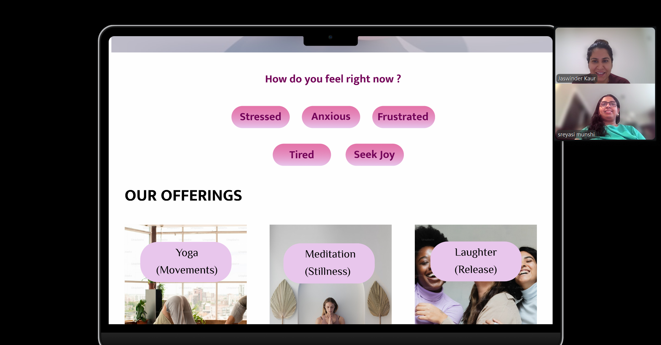

Iterations and Improvements:
Based on the tester’s feedback, the following key enhancements were implemented:
- Persistent Navigation: The primary navigation bar, including the "Home" button, was made static and accessible regardless of scroll position, greatly improving navigation efficiency.
- Dynamic Images: Select static images were made clickable and interactive to enhance user engagement.
- Visual & Flow Polish (Planned): Further work was prioritized to smooth page transitions (eliminating the 'glimpse' bug), implement the suggested 3D effect for buttons, and ensure all social media contact links are fully functional.
These iterations ensured the final prototype was robust, highly usable, and directly responsive to expert UX feedback.

E: Reflect

Reflection on the Design Process
The prototype design for The Gentle space employed several foundational principles to ensure a cohesive, calming, and intuitive user experience focused on yoga, meditation, and laughter.
- User-Centered Design (UCD):
The process was driven by user needs and expert feedback. Key features like persistent navigation were prioritized and implemented to directly enhance usability and communication.

- Consistency:
Users expect the primary logo to function as a reliable home anchor from any screen. Violating this established convention creates confusion.

- Aesthetic-Usability Effect: The visual polish of the design was prioritized. Feedback was utilized to enhance the look and feel, such as exploring 3D effects for buttons, reinforcing the idea that an aesthetically pleasing design is perceived as more trustworthy and usable.

- Flow & Stability: A seamless flow is crucial for a positive experience; flickering breaks immersion and suggests technical instability. Optimizing transitions supports a perception of reliable quality.

